**Assignment 11.3**

**Problem Statement:**

Write a Pig UDF to find the tweets posted by @realDonaldTrump from the given dataset.

**Input:**

[**https://github.com/prateekATacadgild/DatasetsForCognizant/blob/master/clinton-trump-tweets.zip**](https://github.com/prateekATacadgild/DatasetsForCognizant/blob/master/clinton-trump-tweets.zip)

**Program:**

* **UDF**

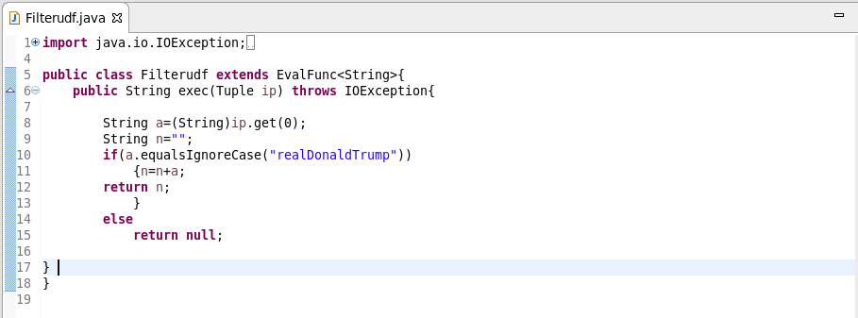

* **Pig script**

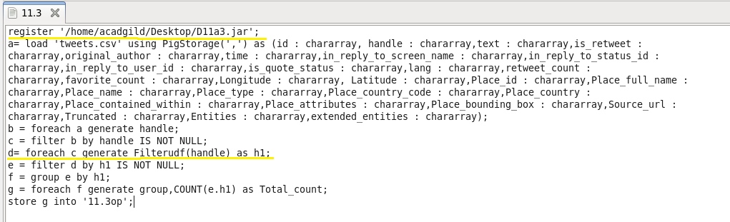

**Output:**

